**EMERGING METHOD FOR EARLY DETECTION OF FOREST FIRE**

**PROJECT REPORT**

**1.1INTRODUCTION:**

Impact of environment is based by five elements those are land, water, air, sky and fire. Natural disasters are caused by all of these. Earthquake through land and, Tsunami through water, Cyclone through wind, heavy rains are caused by sky and forest destruction is caused by fire. It is up to us as humans to correct the destruction caused by nature. Detection and prevention is more important than thinking about fixing after the event. So, e, we have come together as an engineering team to propose and develop a prototype solution to these issues using our acquired technical knowledge as computer science engineering students for our senior design project this semester. Our project idea entitled, “Forrest Fire Detection System,” will be comprised of multiple systems working in tandem: In summary, we aim to reduce the social, economical, and environmental impacts brought on by forest fires.

* 1. **Project Overview:**

The importance of forest environment in the perspective of the biodiversity as well as from the economic resources which forests enclose is more than evident. Any threat posed to this critical component of the environment should be identified and attacked through the use of the most efficient available technological means. Early warning and immediate response to a fire event are critical in avoiding great environmental damages. Fire risk assessment, reliable detection and localization of fire as well as motion planning, constitute the most vital ingredients of a fire protection system. Through our prior knowledge Supervised and unsupervised learning, Regression Classification and Clustering Artificial Neural Networks and Convolution Neural Networks our team has an overall idea about Emerging Methods for Early Detection of Forest Fires. The first task is to collect the data because in Convolution Neural Networks, as it deals with images, we need training and testing data sets. After that we pre-process the image and train our deep-learning model. The next step is video analysis to get the prediction for the input frames then we train our Image classification Models on IBM Cloud using IBM Watson Studio Service.

* 1. **Purpose:**
* Image Processing:

Image processing is processing of images using mathematical operations by using any form of signal processing for which the input is an image, such as a photograph or video frame the output of image processing may be either an image or a set of characteristics or parameters related to the image. Most image-processing techniques involve treating the image as a two dimensional signal and applying standard signal processing techniques to it.

* Model building:

This stage is dedicated to training the agent to generate an accurate and flexible model. The same dataset is divided into two parts. One is used for training purpose whereas the other is used for validation of the model. It uses a Decision tree based approach for the classification purpose.

* Video analysis:

Most important part is video analysis; in this stage we use all the Cnn and Ann models to capture and analysis the fire.

* Final deliverable:

Deployment is involved in this final deliverable, we can predict in this stage.

These all processes are to achieve our purpose

**2. Literature Survey:**

**2.1Existing Problem:**

Forest fires are a major environmental issue, creating economic and ecological damage while endangering human lives. There are typically about 100,000 wildfires in the United States every year. Over 9 million acres of land have been destroyed due to treacherous wildfires. It is difficult to predict and detect Forest Fire in a sparsely populated forest area and it is more difficult if the prediction is done using ground-based methods like Camera or Video-Based approach. Satellites can be an important source of data prior to and also during the Fire due to its reliability and efficiency. The various real-time forest fire detection and prediction approaches, with the goal of informing the local fire authorities.

**2.2 References:**

[1]. Chi Yuan, Zhixiang and Youmin Zhang, “UAV-based forest fire detection and tracking using image

processing Techniques,” Proc. of IEEE International in Image Processing, pp. 978-1-4799-6009- 5/15,

2015.

[2]. T. Chen, P. Wu and Y. Chiou, “An early fire detection method based on image processing,” Proc.

of IEEE International in Image Processing, pp. 1707-1710, 2004.

[3]. B. U. Toreyin, Y. Dedeoglu and A. E. Cetin, “Flame detection in video using hidden morkov

Models,” Proc. of IEEE international conference on Image Processing, pp. 1230-1233, 2005.

[4]. B. U. Toreyin, Y. Dedeoglu, U. Gudukbay and A. E. Cetin “Computer Vision based method for real time fire and flame detection”, Pattern Recognition Lett.27(1) pp. 49-58, 2006.

[5]. T, Celik, H. Demirel, and H. Ozkaramanli “Automatic firedetection in video sequences”, Proc. of

European signal processing Conference (EUSIPCO 2006). Florence, Italy, September 2006.

[6]. W. Krull, I. Williams, R. R. Zakrzewski, M. Sadok, J. Shirer and B. Zeliff, “Design and test methods

for video basedcargo fireverification system for commercial aircraft”, Fire Saf. J. 24(4), pp.290-300,

2006.

[7]. G. Marbach, T. Brupbacher, “An Image processing technique for fire detection in video”, Fire saf.

J. 41(4) pp. 285-289, 2006.

[8]. Wen-Bing Homg, Jim-wen Peng and ChinYuan Chen, “A new image based real time flame

detection method using colour analysis”, Proc. of IEEE Network sensing and Control, ICNSC, pp. 100-

105, 2005.

[9]. Turgay and Hasan Demirel, “Fire detection in video sequences using a generic colour model” Fire

Saf. J. 44, pp. 147-158, 2009.

[10]. V. Vipin, “Image Processing Based Forest Fire Detection”, IJETAE, Vol. 2, Issue 2, Feb. 2012.

[11]. Signal detection theory and Psychophysics, Wiley Newyork, 1966.

[12]. Wild fire Operations research Group Retrieved August 11, 2006.

**2.3 Problem statement definition:**

* Image processing
* import The ImageDataGeneratorLibrary.
* defining the parameters.
* imagepreprocessing.
* Model building
* Adding CNN Layer
* Adding Dense Layers
* Configuring the Learning Process
* import_Model_Building_Libraries
* Initializing the model
* Save the model
* Training the model
* predictions.
* Video analysis
* Twillo_service_creation
* OpenCV_for_videoProcessing
* Sending_Alert_Message.
* Final deliverable
* TRAIN_CNN_ON_IBM_CLOUD
* IBM cloud Account

**3. IDEATION AND PROPOSED SOLUTION:**

**3.1 Empathy map canvas:**

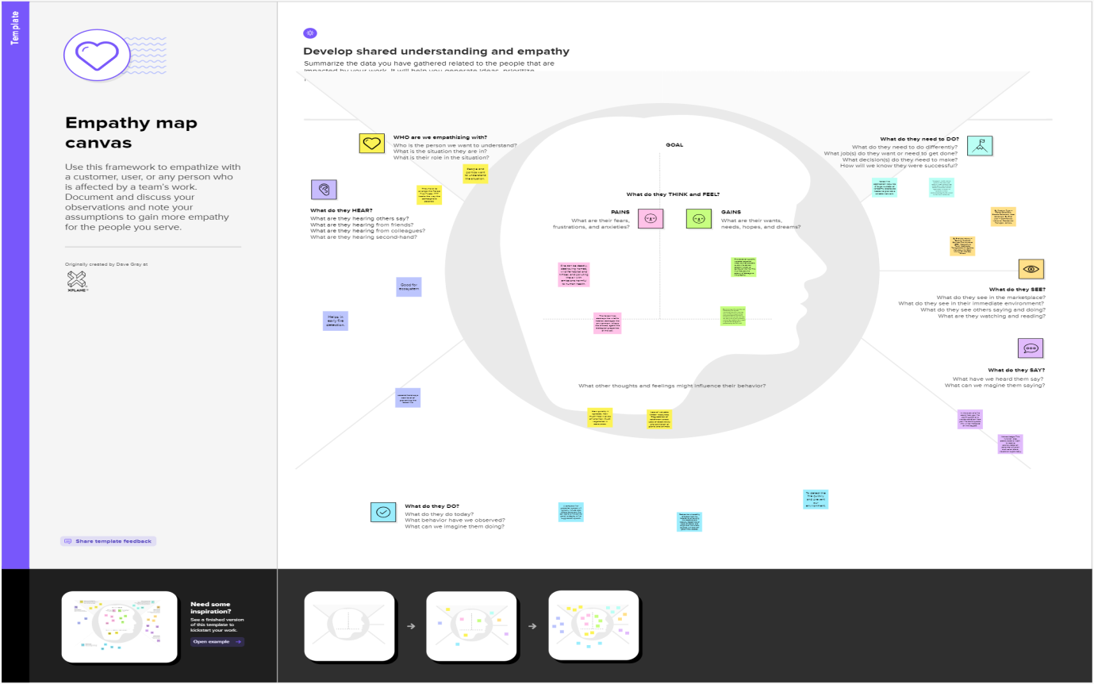

**3.2. Ideation & Brainstrome:**



**3.3 Proposed solution:**

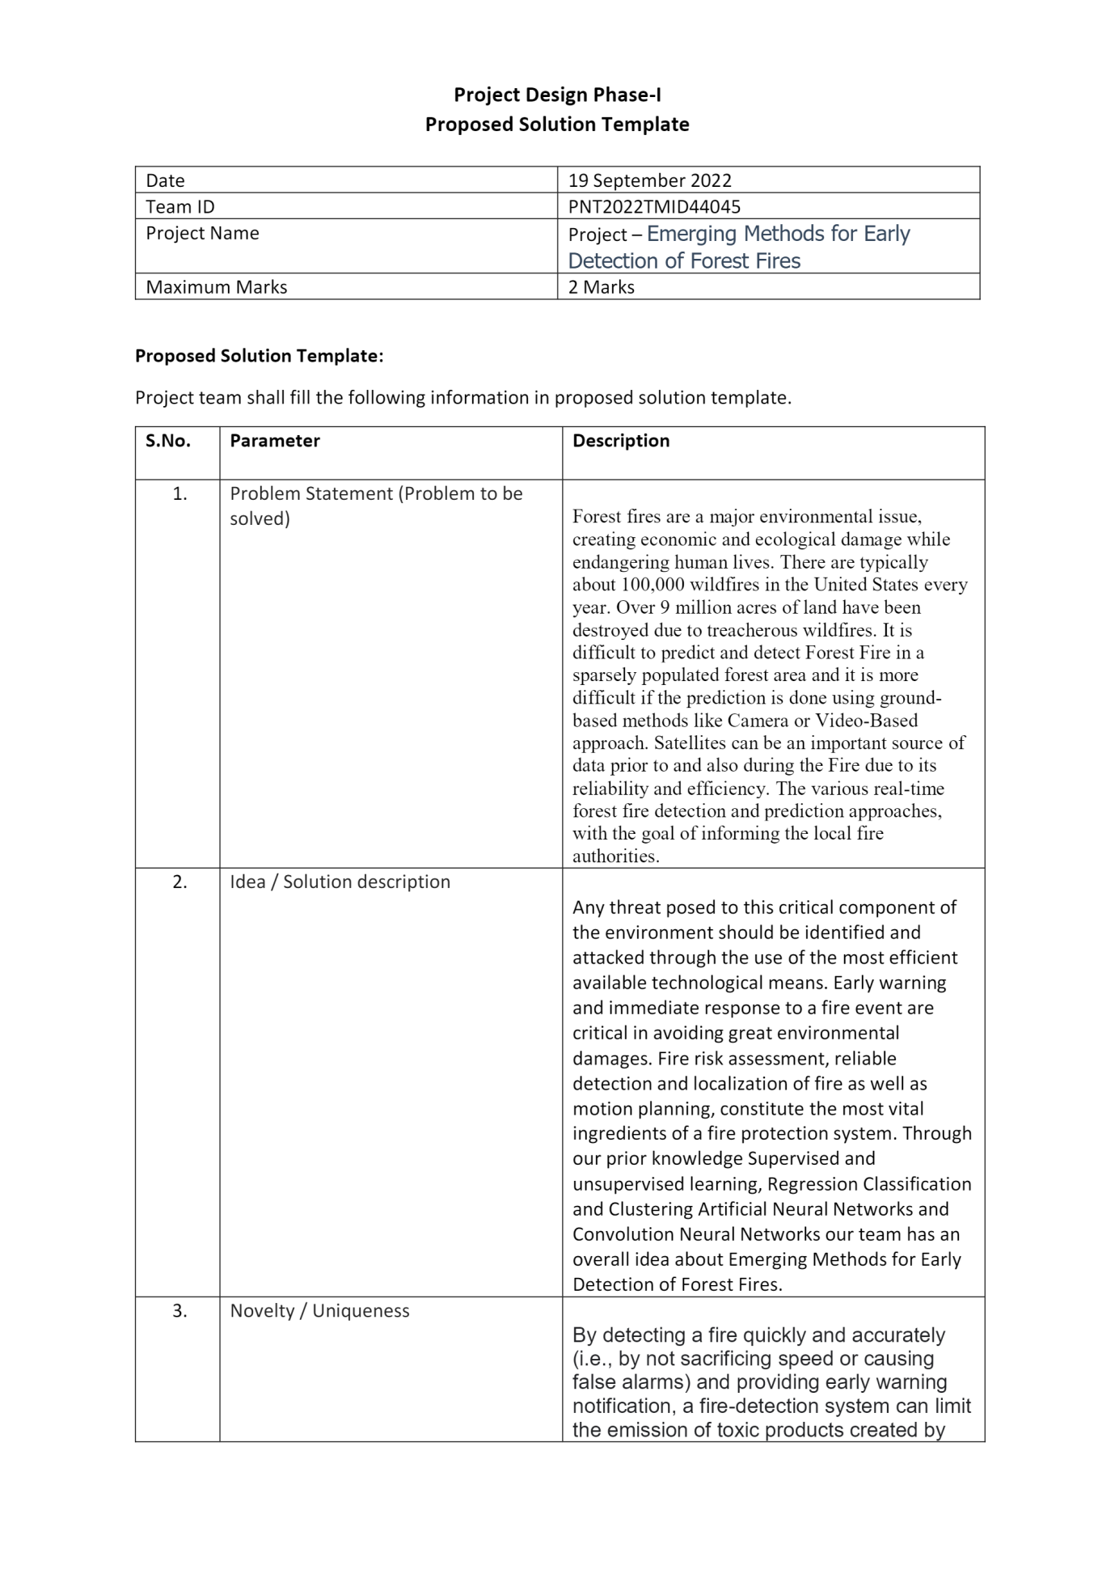

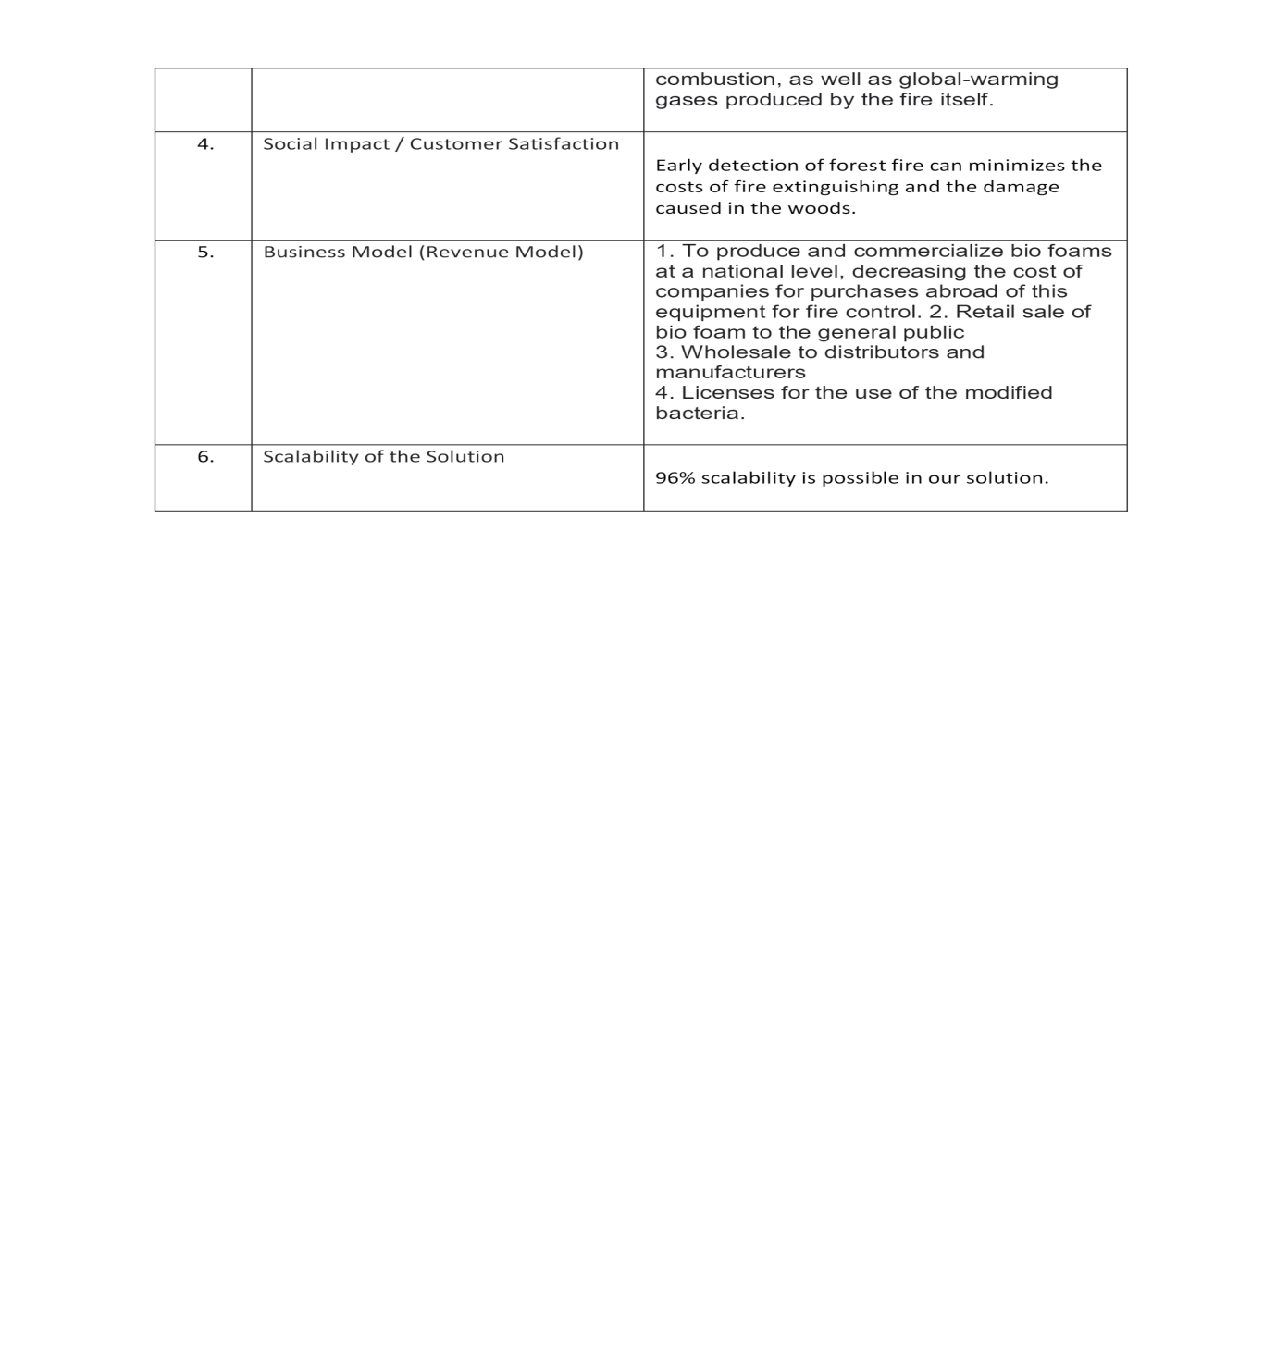

**3.4 Problem solution fit:**





**4. Requirement Analysis:**

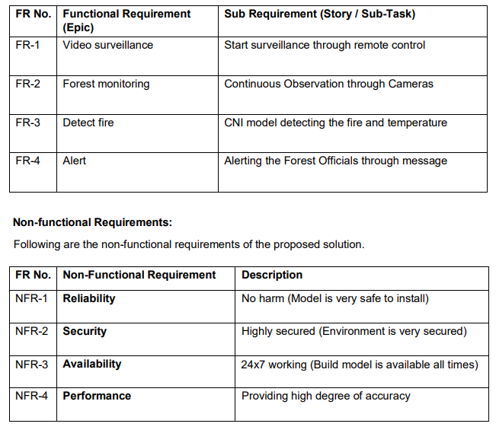

**4.2 Data flow diagram**

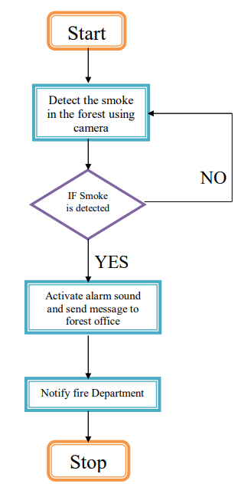

**5. Solution & Technical Architecture:** 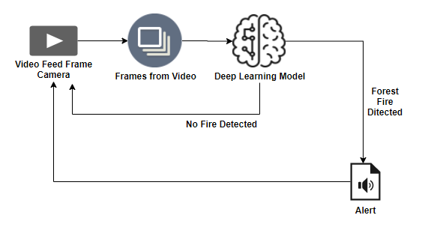

* Forest fires are a major environmental issue, creating economic and ecological damage while endangering human lives.
* There are typically about 100,000 wildfires in the United States every year. Over 9 million acres of land have been destroyed due to treacherous wildfires.
* It is difficult to predict and detect Forest Fire in a sparsely populated forest area and it is more difficult if the prediction is done using ground-based methods like Camera or Video-Based approach.
* Satellites can be an important source of data prior to and also during the Fire due to its reliability and efficiency.
* The various real-time forest fire detection and prediction approaches, with the goal of informing the local fire authorities.

**5.3 User stories:**

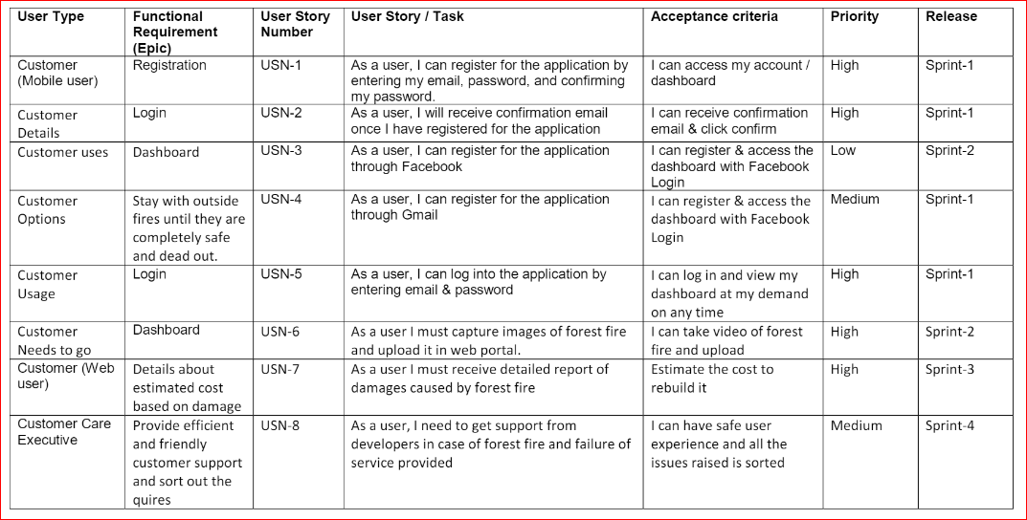

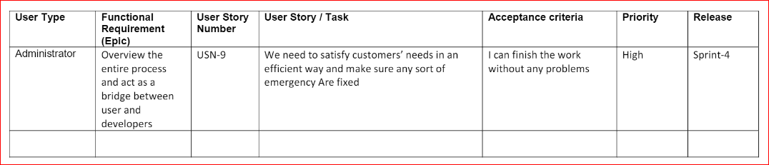

**6. Project Planning & Scheduling:**

**6.1 Sprint planning & estimation:**

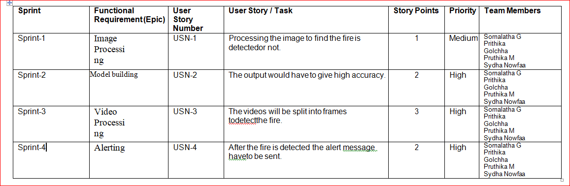

**6.3Sprint Delivery Schedule:**

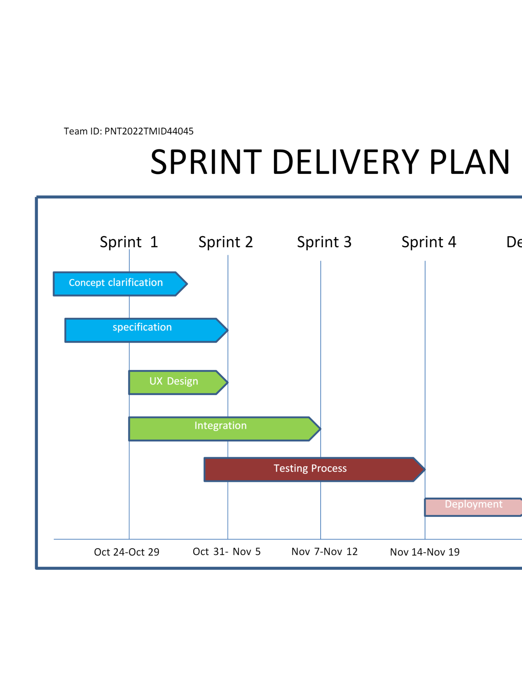

**7. Coding & Solution:**

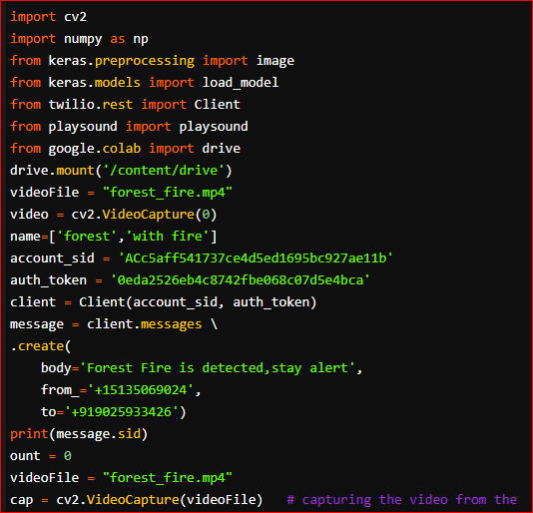

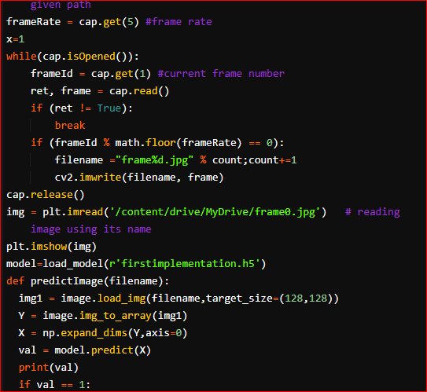

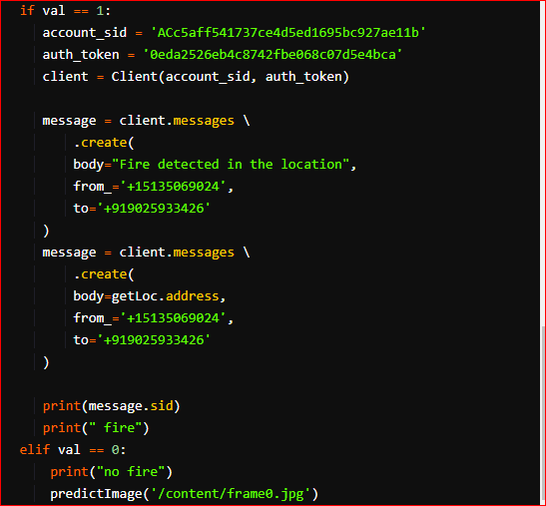

**Output:**

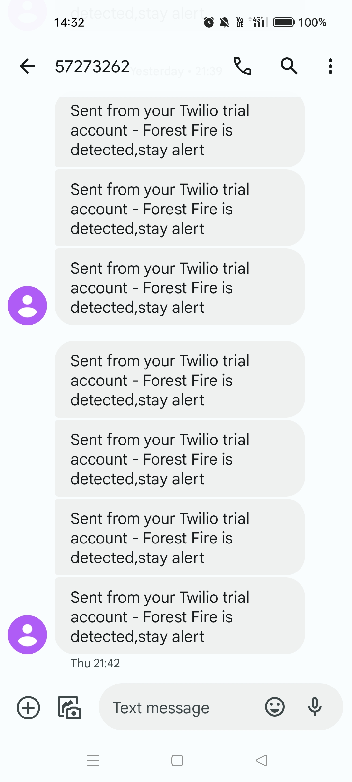

**8. Testing:**

**8.1 Test cases**

|  |  |  |  |  |
| --- | --- | --- | --- | --- |
| **Comparison** | **Human based observation** | **Satellite System** | **Optical cameras** | **Wireless sensor network** |
| Efficiency and Practically | Low | Low | Medium | High |
| Fire behavior | **-** | **Yes** | **-** | **Yes** |
| Detection delay | Long | Very long | Long | Small |
| Fire detecting accuracy | Low | Medium | Medium | High |
| Alarm capacity | Low | Low | Medium | Medium |
| Cost | Low | High | High | Medium |

**8.2 User Acceptance Testing:**

|  |  |  |  |  |  |
| --- | --- | --- | --- | --- | --- |
| Resolution | Severity 1 | Severity 2 | Severity 3 | Severity 4 | Subtotal |
| By design | 10 | 4 | 2 | 2 | 9 |
| Duplicate | 1 | 1 | 3 | 0 | 5 |
| External | 2 | 3 | 1 | 1 | 7 |
| Fixed | 11 | 2 | 4 | 20 | 38 |
| Not reproduced | 0 | 0 | 0 | 0 | 0 |
| Skipped | 0 | 0 | 1 | 1 | 2 |
| Won’t fixed | 0 | 5 | 2 | 1 | 8 |
| Total | 24 | 14 | 13 | 26 | 77 |

**Testing analysis:**

|  |  |  |  |  |
| --- | --- | --- | --- | --- |
| Section | Total cases | Not tested | Fail | Pass |
| Print Engine | 7 | 0 | 0 | 7 |
| Client application | 52 | 0 | 0 | 52 |
| Security | 2 | 0 | 0 | 2 |
| Outsource shipping | 3 | 0 | 0 | 3 |
| Exception reporting | 9 | 0 | 0 | 9 |
| Final report output | 5 | 0 | 0 | 5 |
| Version control | 2 | 0 | 0 | 2 |

**9. Result:**

**9.1 Performance matrices:**

|  |  |  |  |
| --- | --- | --- | --- |
| SI.NO | Characteristics | Description | Technoloy |
| 1. | Open-source frame work | Python flask frame work is used | Technology of open-source frame work |
| 2. | Security implementation | MAC and preventive control security is used | Eg: SHA 256 encryption |
| 3. | Scalable architecture | High scalability with 3-tire architecture | Web server, CSS, Java script application python, Anaconda database server-IBM DB2 |
| 4. | Availability | Use of load balancing to distribute traffic across server | IBM load balancer |
| 5. | Performance | Enhance the performance by using IBM CDN | IBM content delivery network |

**10. Advantages:**

* This system effectively detects and verifies the presence of fire in forest regions.
* The addition of Region proposals in CNN layers can result in better accuracy as well as faster execution.
* Our system can verify the presence of fire in the forest with an accuracy of 97.29% from the RCNN model.
* This will help in the beginning phases of fire identification and assist with restricting the fire to restricted regions to prevent large-scale damage.
* This system focuses on observing the forests without steady human supervision.

**Disadvantages:**

* Does not have global market penetration like other competitors
* Limited battery capabilities.
* Limited data transfer and communications capabilities
* Will only be available on the west coast at product

**11. Conclusion:**

Wildfires emit billions of tones of carbon dioxide into the atmosphere which causes harm to climate and living organisms. This can also impact the carbon cycle due to excess CO2 and loss of vegetation. High-intensity forest fires destroy flora and fauna. Forest fires have an immediate effect on mortality, not associated with accidental deaths, which is a significant public health problem, especially if the fire occurs near a densely populated area. So, forest fire detection system help to minimize the effect of all living beings.

**12. Future Scope:**

* Development of micro electrical system (MIES), wireless network system is expected to be widely in use.
* MEMS are the combination of electrical devices and mechanical structure at an extremely small scale. Many researcher need to be done so as to implement MEMS in WSN
* Moreover IoT is expected to have dramatic impact in our lives in nature. WSN’s will be integrated into IoT and innumerable sensor nodes will join the internet. They will cooperate with other nodes to sense and to monitor the environment E.g. Smart driver system
* Change In The Micro Climate Of The Area Resulting In Healthy Living Conditions
* Soil erosion disaffecting productivity of soils and agricultural production;
* Avoid Ozone Layer Depletion

**13. APPENDIX:**

* Source Code
* GitHub & Project Demo Link

*Submitted by, (project Id:* ***PNT2022TMID44045****)*

1. *Sornalatha G*
2. *Pruthika M*
3. *Prithika Golchha*
4. *Sydha nowfaa N*